**Dragon Cave**

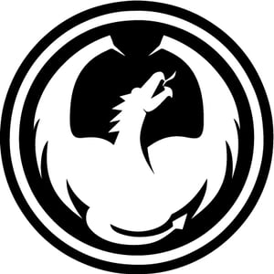

In the Dragon Cave game, you may be a member of Alliance which contains four human players with their solider try your best to conquer the dragon cave. Or, you may be the Dragon to eliminate all the Alliance force. There could be only one winner in this game, either the dragon or the player who conquer the cave. Player could make use of their soldiers they must fight with each other, even their Alliance. Player could pray for the god to bless them in the temple and get advantage in this game. Use your strategy and win the game. May the god bless you.

**Contents:**

1 game board

4 artifact cards

24 soldier cards: 6 sword guards, 6 spearmen, 6 archers.

12 event cards

* **Map:**

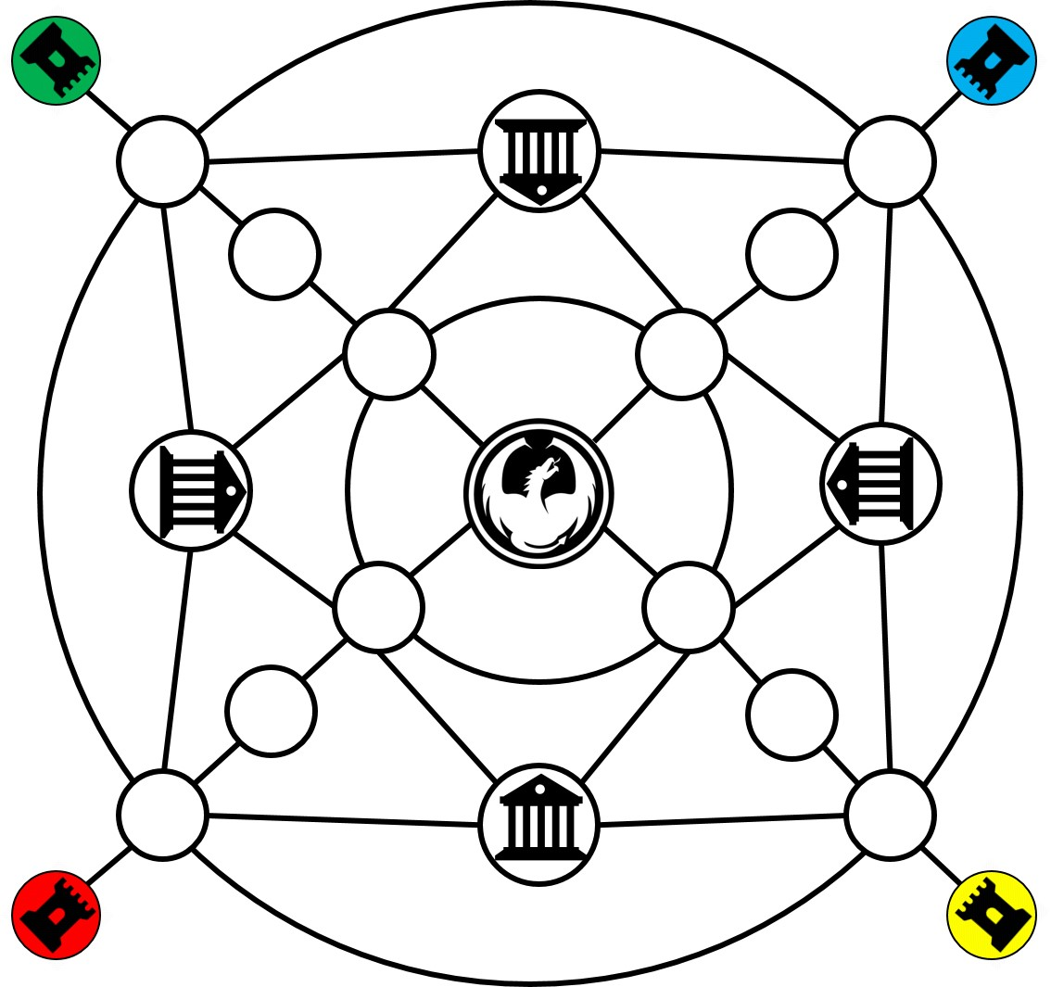

Dragon cave, the base of dragons, the place every human players want to go in. There are four dragons in this cave, and when there is no dragon in this cave and human players own it, the human wins.



Castle, where the kings of humans live, when the king in the castle died, the corespondent player lose the game.



Temple, anyone go into the temple will automatically trigger a random event, may be good or bad, depend on your luck.

* **Event cards:**

The 12 event cards are made up by 9 cards which have random events and 3 cards which have none event. Each random event is different, So triggering different events will have different effects on the player.

|  |  |
| --- | --- |
|  | Active a unit you want. That unit could make action by its’ owner. This card does not change the game sequel. |
|  | Change this unit’s position with any other unit you have. |
|  | Freeze (cannot make action) one player you want one round. |
|  | Choose a unit you want and make it invisible (cannot be attack by another unit) for one round. |
|  | God give another change for this unit which pay in the temple make action. |
|  | Rage fill with the soldier’s mind. They are force to fight with each other. Select two unit to make then fight without reason. |
|  | God is kind. You can resurrection a unit you want. |
|  | Change the game sequel forever. |
|  | You can move to any place you want. Of course, there should not be occupied by another unit. |
|  | God is in vacation. God do not receive your pray, nothing happened. |

* **Soldier cards:**

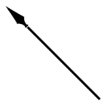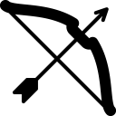

There are three different kinds of soldier cards which are sword guard, spearman, archer. Each human player holds three different soldier cards and the dragon player have multiple solider cards which the number is the number of human players multiply by three. For example, if there are four human players, then the dragon player has four sword guards, four spearmen and four archers totally 12 cards. There is a relationship between the three kinds of soldiers to restrain each other, that is sword guard wins archer, archer wins spearman and spearman wins sword guard. In the condition of the same type of soldier, the dragon soldier is stronger than human soldier. However, the exception condition is when a soldier holds an artifact ( For details, please refer to the introduction of artifact). The player ends game when all of his soldiers has been killed.

* **Artifact cards:**

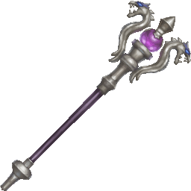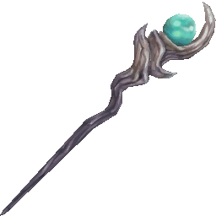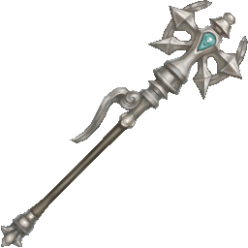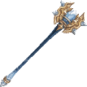

Each human player holds an artifact before the game begins. The four artifacts are different, but the function is the same. For human player, this artifact has two functions: First, this artifact allows the player deploy multiple soldiers in different color one time when holding it. The more artifacts the player holds, the more different color soldiers can be deployed (for example, one player can deploy two soldiers in different colors one time when he has one artifact, he can deploy three soldiers in different colors when he has two artifacts. And so on). Second, it is able to let the solider which holds the artifact wins the battle with the same type solider which not holds the artifact include against the same type dragon solider. The effect can adds when a player holds multiple artifacts. For example, one sword guard which holds two artifacts can beats one sword guard which holds only one artifacts. However, this function can only effect the same type soldier, it is invalid between the different type of soldier. For dragon, there are also two function. First is to allow dragon player deploy multiple dragon soldiers one time, the number of soldier is the number of artifacts player hold plus 1. The second function is the same as human’s.

**Gameplay**

* **Player’s role:**

Each game has 5 players.

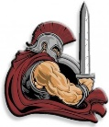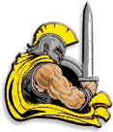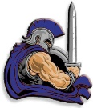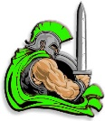

Four human players in Red, yellow, blue, green, four different colors

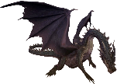

One dragon player.

* **Goal**

Dragon player: kills all human kings or kill all the human soldiers wins.

Human player: only the player who kills the last dragon soldiers or occupy the dragon fortress wins.

* **Basic rules and actions**

1. the human kings are stationed in the human base, can not moving, and holds a artifact at the beginning of the game. After the king was killed, the player ended the game.
2. Before the start of the game, the human player’s soldier cards are placed in the human base and the dragon player choose four soldier cards store at the cave. When turn to the human player’s turn, he can choose to deploy a soldier from the base or move a solider which is out of the base one cave. When turn to the player’s turn, he can choose to deploy a soldier from the cave or move a solider which is out of the base one frame, or add a soldier from the hand to the cave.
3. When the game started, the first dragon player to start the round action first, then the human player in accordance with the order of red green blue in turn to start their own round.
4. Each player can only deploy or move one soldier at one time except he use artifact (For details, please refer to the introduction of artifact).
5. When a player deploys, or moves a soldier, the soldier card is faced down. That means other players don’t know what this soldier card is. This soldier card turns on when it battles with another solider card. The soldier card which lost the battle is regarded as "died", was excluded from the game. This card cannot be returned to the game unless it is resurrected by triggering the resurrection event
6. Each player can only move one frame at one time.
7. When the player moves to the temple location, an event is extracted from the event library at random, and the event is then put back into the event library and shuffled.
8. In the condition that the human king holds the artifact, the player can choose to deploy a soldier with the artifact and move. When this soldier is killed by the dragon player, this artifact return to the kings’ hands. When this soldier is killed by other human player, this artifact falls into other human player king’s hand.
9. If a human player holds artifact, the dragon player need to destroy this human player (kill his king or all his soldiers) to get this artifact.
10. When a human player out of game, the player who killed him can get a soldier's card at random. If the player has artifact, the artifact belongs to the player who destroyed him.

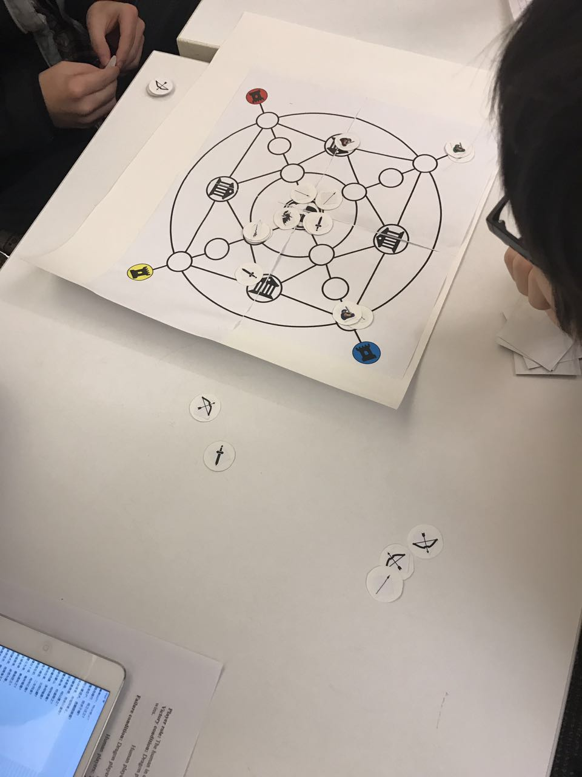

**Credits:**

**Game design**

Tank, Andy, Will, Agnes, Lyu